ARTSS ‘HANDBOOK’

(Please be noted that these information are just for references and may not possibly include all possible conditions, when encountering a problem, keep calm and always treat it with flexibility)

//Basic information:

Wiring diagram:

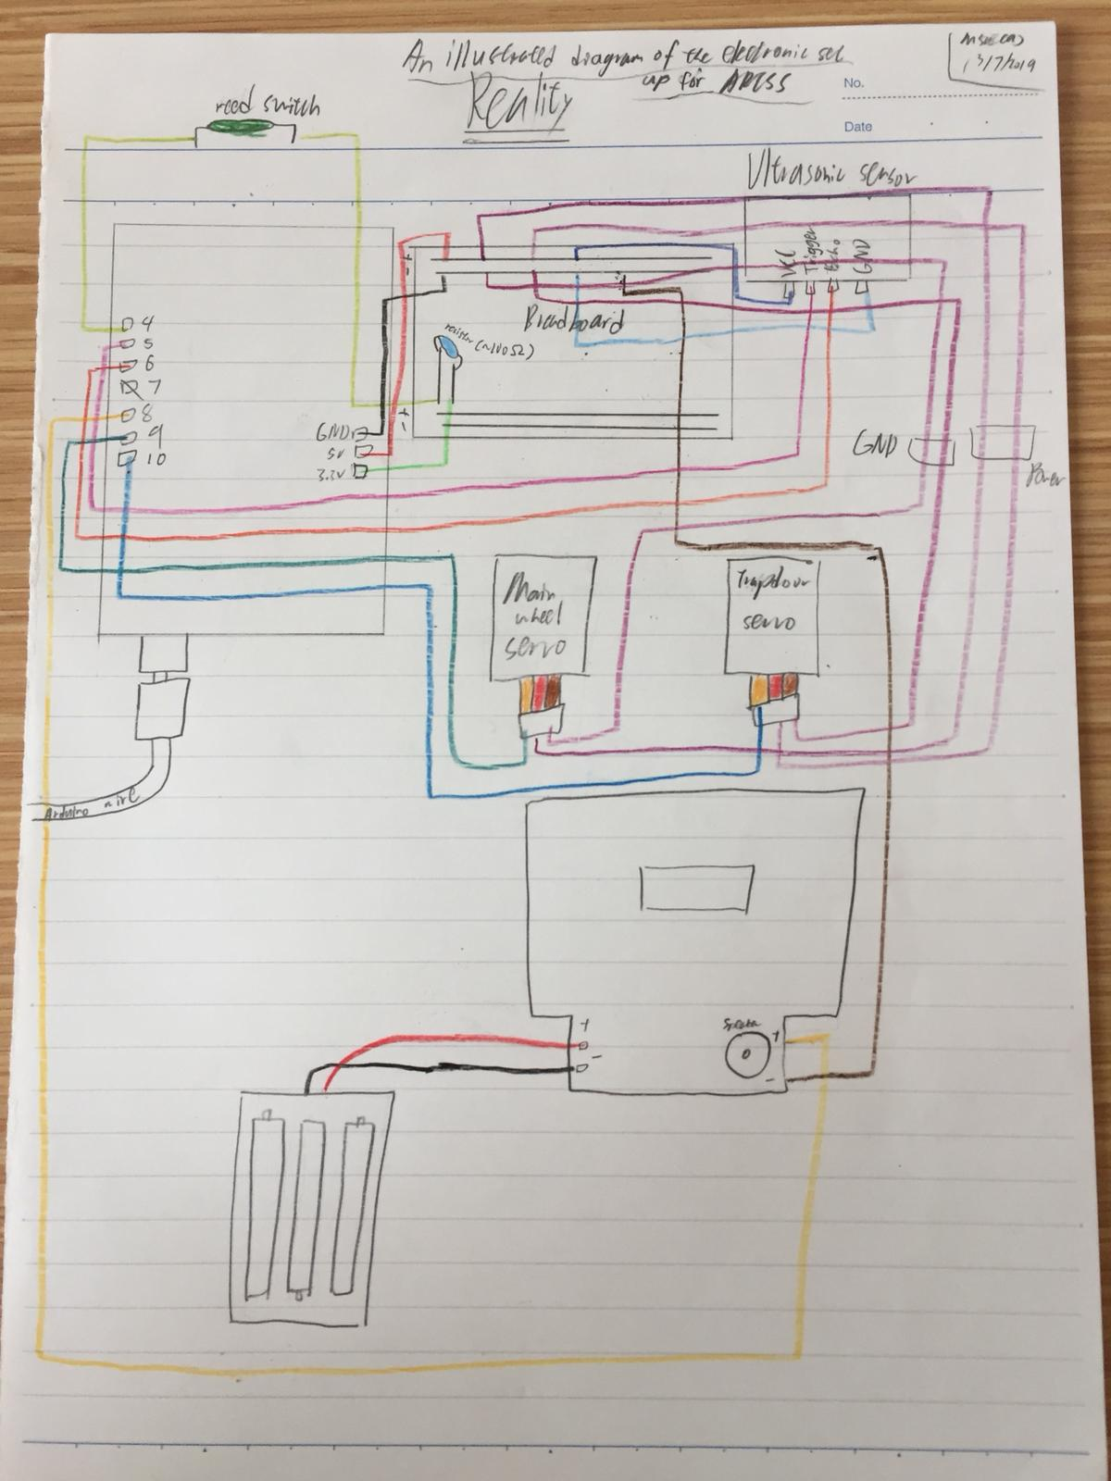

//Basic techniques:

-Arduino

If have:

Problem with uploading -> Go to ‘tools’ (upper left hand corner) -> Check port: COMx (Arduino Uno), check if it is connected to the Arduino board/ change the Arduino wire

-Wires

To check the condition of the wires

-> Set up wire checking system -> check wires’ condition (check if electricity can be transmitted via it properly)

Wire checking system set up

Apparatus required:

-電錶 x 1

-電錶wires x 1 pair

-Crocodile clip x 2

-Battery box (2 slot) x 1

-Batteries (functional) x 2

Set up:

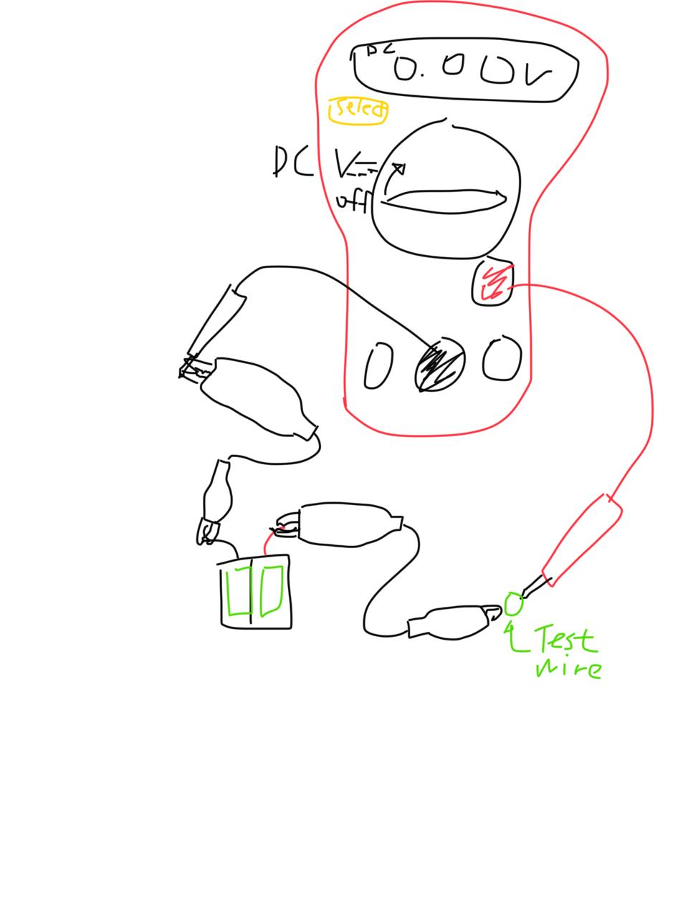

Pic. 1

Set up the above set up (beware of the positive and negative terminals of the battery box) -> turn the switch to test DC voltage (one slot in clockwise direction) -> press select till the unit in 0.00…V -> ready to test [For testing the whether a part could conduct electricity]

[P.S. can try testing with the resistance function, however the IT room’s 電錶 doesn’t seem to be able to test that accurately thus suggest the above method]

To check if the batteries are working, set up the set up without the crocodile clips and the battery box, test the battery directly

Conditions:

(Normal)

If the voltage obtained is about the batteries’ tested voltage, the wire is alright

(Abnormal)

1.Else it is problematic

Solutions:

S1.Replace the wire and with another wire that passes the above test / rub the wire metallic parts with sand paper and test it again (some new wires are being covered with a thin layer of coating, which inhibits the electricity from passing through)

-Electronics connection (directly connected with other metallic parts)

Condition:

(Looks normal)

Silvery

(Looks abnormal)

1.Gray and dull

(Normal)

Conducts electricity with really less resistance (often undetected)

(Abnormal)

2.Fails to transmit electricity properly or isn’t stable in doing so

Solutions:

S1. Rub the connection parts with sand paper or remove the oxidized parts by cutting it away, remove the while part only if necessary

S2. Rub the connection parts with sand paper or remove the oxidized parts by cutting it away, remove the while part only if necessary -> check again -> still unstable -> replace the part with another if possible to lower the risk

//Essential guidelines (for discrete systems or parts) :

-Ultrasonic sensor

To check the condition of the ultrasonic sensor

-> Open Arduino -> Open the sketch ‘//Ultrasonic sensor’ (a button at the upper left hand corner) -> Connect the computer and the Arduino board with the Arduino wire -> Upload program (a button at the upper left hand corner) -> Open serial monitor (upper right hand corner)

Conditions:

(Normal)

Suppose a value > 0 and not error is shown on the serial monitor constantly provided that nothing is blocking its range

(Abnormal)

C1.If error is shown in this case, it indicates that the ultrasonic sensor system has some problem

(Abnormal)

C2.If the value fluctuates too constantly with a large degree ~> 10 cm

(Normal)

The serial monitor will show error if the object is too close to the ultrasonic sensor

I.e. touching the detecting regions of the ultrasonic sensor

Solutions:

S1. (Serious problem)

1.Check wiring (ultrasonic sensor circuit)

2.Check wires’ condition

3.Use another ultrasonic sensor

S2. (Minor problem)

1.See if the fluctuation stops -> fine

2.Check if there are any possible sources of affecting the functioning of the ultrasonic sensor

I.e. anything that may cause serious echoes of ultrasonic, enclosed environment that facilitates the echoing effect of ultrasonic

-> get rid of these possible sources if possible

-Metal detector

To check the conditions of the metal detector

-> Open Arduino -> Open the sketch ‘//Metal Detector’ (a button at the upper left hand corner) -> Connect the computer and the Arduino board with the Arduino wire -> Upload program (a button at the upper left hand corner)

-> Open serial monitor (upper right hand corner) + Check mechanically

Condition:

(Normal)

1 seen on the serial monitor if a metallic object is placed near the metal detector (<2cm), else it is 0

(Abnormal)

Doesn’t match the above description

(Normal)

Beep sound heard when a metallic object is placed near the metal detector (<2cm)

(Abnormal)

2.No beep sound when a metallic object is placed near the metal detector (<2cm)

Solution:

S1,2.

Check if the metal detector has being supplied with three same type of functional battery, always remove the batteries when not using it

/

Check the wiring of the metal detector part, tape parts that are loose to corresponding metallic parts tightly

(If condition 2. doesn’t exist but condition 1. exist, it signifies that the individual part_metal detector is alright, but not the part connecting the Arduino board and metal detector)

(If the metal detector isn’t sensitive enough, adjust the variable resistor of the metal detector such that it just doesn’t beep when no metal is nearby, then the sensitivity is at max)

-Servo motor

Main wheel servo is basically a two directional continuous motor (MG996R)

Trapdoor servo is basically a 120 degrees two directional motor (MG995)

Check the servo motors

-> Open Arduino -> Open the sketch ‘//Main Servo’, ‘//Trapdoor’ (a button at the upper left hand corner) -> Connect the computer and the Arduino board with the Arduino wire -> Upload program (a button at the upper left hand corner)

-> Check mechanically

Condition:

(Normal)

Moving

(Abnormal)

1.Not moving

Solution:

S1. Check wirings -> still fail -> may need to replace it with another servo motor of the same type, repeat the test to check if the servo motor is alright

-Reed switch

Check reed switch

-> Open Arduino -> Open the sketch ‘//reedswitch’ (a button at the upper left hand corner) -> Connect the computer and the Arduino board with the Arduino wire -> upload program (a button at the upper left hand corner)

Condition:

(Normal)

Functional

(Looks normal)

No cracks or slightly broken parts

(Abnormal)

1.Non-functional

(Looks abnormal)

2.Cracks are observed on the reed switch/metallic plates of the reed switch are really loose

Solutions:

S1. Replace the reed switch with the same type of reed switch (provided that it looks normal) and commit the test again/ check wiring and connection and position

S2. Replace the reed switch with the same type of reed switch (provided that it looks normal) and commit the test again in order to avoid risking to fail even though it may seem to work properly

-Reed switch and main wheel servo

Functioning position:

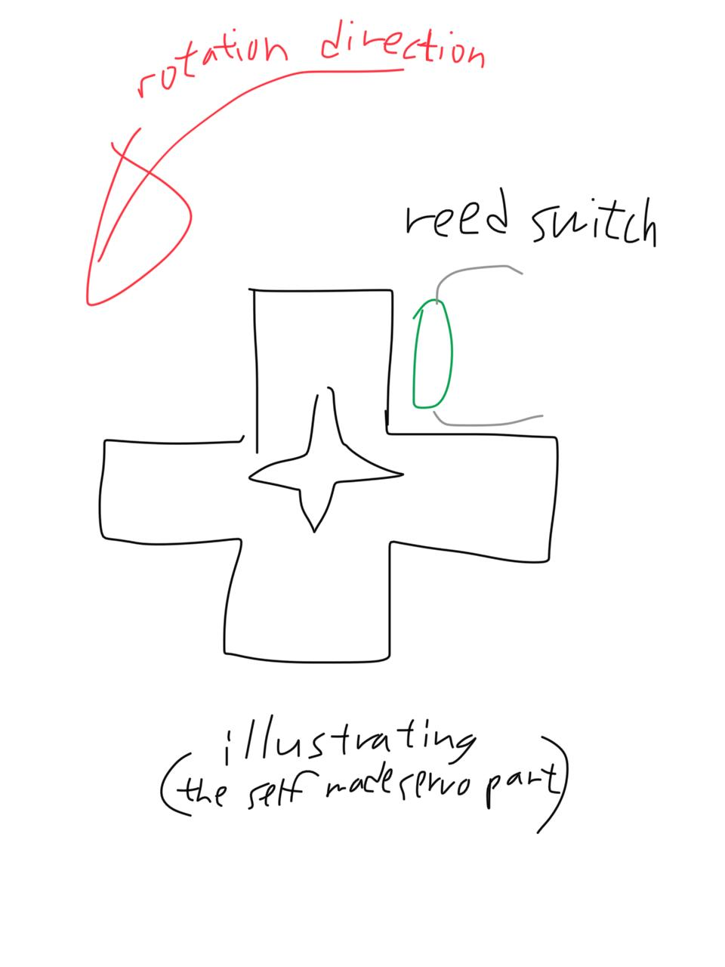

Suppose the reed switch should have its best performance at such position

The system will work if the reed switch is ~1cm near that part, but not over close

There is a program for checking whether if they function well, thus aid determining a good position:

-> Open Arduino -> Open the sketch ‘//reedswitch+mainservo combination’ (a button at the upper left hand corner) -> Connect the computer and the Arduino board with the Arduino wire -> Upload program (a button at the upper left hand corner) -> Figure out if they function well mechanically

//Basic hecking:

1.Check if the trapdoor and main wheel has dislocated

2.Check the whole machine with program ‘//Finalize presentation 3.0’

3.Double check wiring even though it may function well (there may be possible loosen wires)